Software Engineering Logbook Scaffold
A Comprehensive Structure for Consistent and Clear Documentation
Introduction 1
Purpose of the Logbook 1
Core Sections of the Logbook Scaffold 2
1. Daily Log Entries 2
Best Practices for Maintaining a Logbook 2
Sample Logbook Entry Example 3
Logbook Scaffold: 5
Logbook Entries: 6

Introduction
A software engineering logbook is a critical tool for professionals and students alike, serving as a detailed chronicle of progress, challenges, decisions, ideas, and learnings throughout the lifecycle of a software project. Properly maintained, a logbook enhances communication, supports reproducibility, facilitates teamwork, and provides a valuable historical record for future reference.

Purpose of Part A Logbook
The entries of this logbook should focus on your decision making surrounding the design of the project and how you have completed each section of the task.

Core Sections of the Logbook Scaffold

1. Daily Log Entries
- Date: 8/1/26
- Entry Author: Fred Gaffey
- Image of changes: Supporting image(s) of documents or code associated with contents of log
- Summary of Activities: Detailed account of work done, including coding, testing, research, debugging.
- Challenges Encountered: Issues, bugs, roadblocks, misunderstandings.
- Solutions and Actions Taken: How were the challenges addressed? What was tried and what worked?
- Learnings: Insights or new knowledge gained.
- Next Steps: Planned actions for the subsequent sessions.
- Code Snippets: Reference, describe, and annotate key pieces of code (avoid dumping large code blocks).
- Version Control Activity: Record commits, branch merges, tagging, and repository organization.

Best Practices for Maintaining a Logbook
- Update Regularly: Log entries should be made daily or immediately after significant work sessions.
- Be Detailed, Yet Concise: Capture enough context to be useful, but avoid unnecessary verbosity.
- Use Clear, Unambiguous Language: Especially when describing problems or decisions.
- Attach or Reference Supporting Materials: Diagrams, screenshots, code snippets, or related documents.
- Keep Logbooks Organized: Use clear headings, bullet points, and date stamps for easy navigation.
- Review and Reflect: Regularly revisit previous entries to identify patterns, risks, and areas for improvement.

Sample Logbook Entry Example
Date: | 22/08/2025
Title: | Integrating Database Functionality for DogMatch Web App
Author: | [Your Name]
Tasks Description: | Implemented a PostgreSQL relational database to store user profiles, dog details, match history, and messaging data. Established secure connections between the web app backend (Node.js/Express) and the database, created schema, and configured ORM (Sequelise) for data modeling and queries.
Image: | 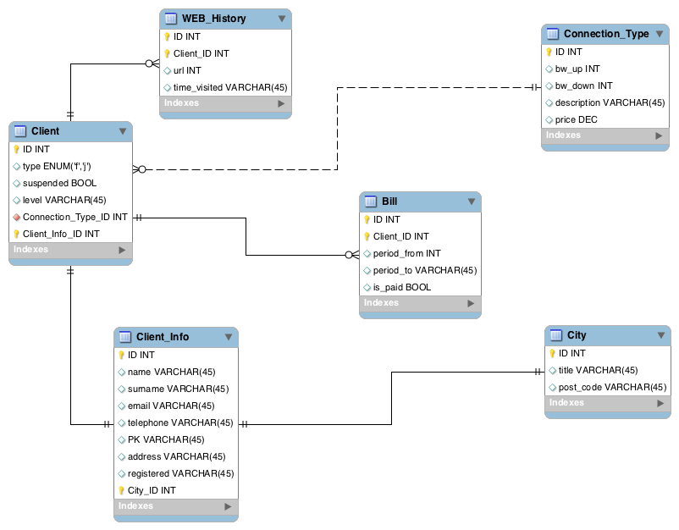e
Logbook Entry: | - Summary of Activities: Today, I architected and deployed an initial database layer for the DogMatch web application—our “Tinder for Dogs.” The focus was to ensure scalable storage for user accounts (owners), dog profiles (name, breed, age, photos, bio), swipes/likes (match history), and in-app chat messages. I set up a PostgreSQL instance, designed normalized tables, and implemented associations (one-to-many: user to dogs; many-to-many: dogs to matches).  - Challenges Encountered: I faced difficulty maintaining data consistency when deleting user accounts—cascade deletions across linked dog and match records were initially not functioning as expected. Additionally, optimizing queries for retrieving potential matches (excluding already-swiped profiles) required refining SQL logic.  - Solutions and Actions Taken: Implemented ON DELETE CASCADE in table relationships and updated Sequelise models to reflect proper associations. For matches, I constructed a subquery-based filter to efficiently exclude previously swiped dogs from query results.  - Learnings: Gained hands-on experience with designing relational data for social matching applications. Understood the importance of data modeling for scalability and the efficiency gains from using ORMs like Sequelise, but also the necessity of direct SQL for complex queries.  - Next Steps: Integrate authentication, refine validation on profile creation, and optimize database indices for common search fields (breed, age, location). Plan to develop unit tests for database transactions and begin work on a data backup strategy.

Logbook Scaffold:
Copy this tables as a scaffold for each of the logbook entries. You should copy this for each new logbook entry, which will be entered into the next section.
Date:
Title:
Author:
Tasks Description:
Image:
Logbook Entry: | Progress since the last entry:  Task Achieved:  Stumbling blocks or issues encountered and how they were managed:  Possible approaches for upcoming tasks:  Reflective comments:
Resources:

Logbook Entries:
Date: | 8/1/26
Title: | Worked out how to do Ollama integration make a basic app
Author: | Freddy Gaffey
Tasks Description: | I downloaded the ai model  Made a basic flaks app that I can ask a ai a question and it will give me a answer to a question.
Image: | 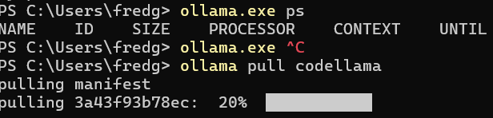  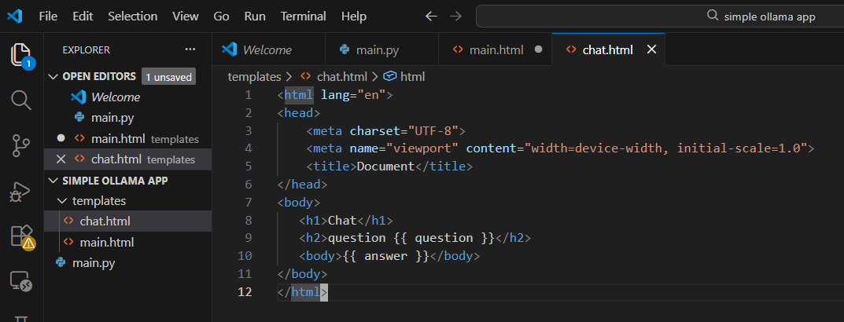  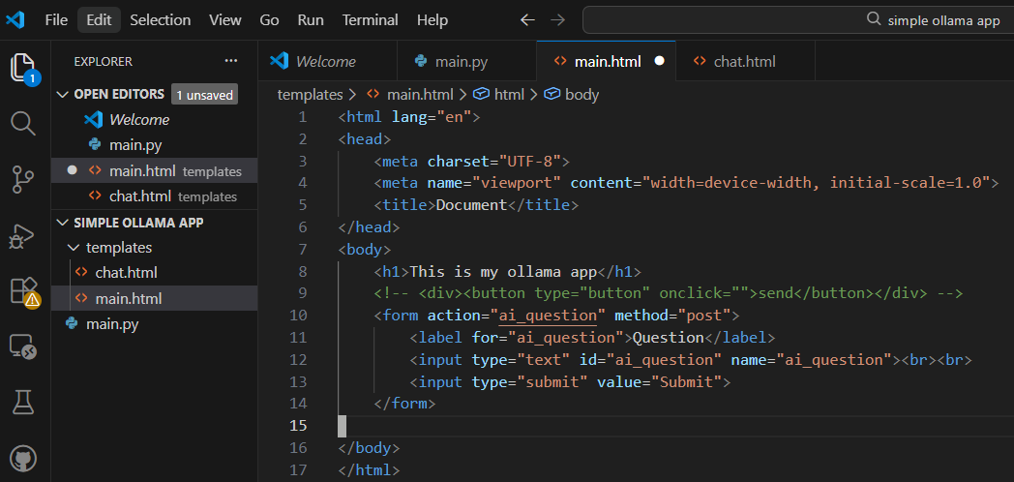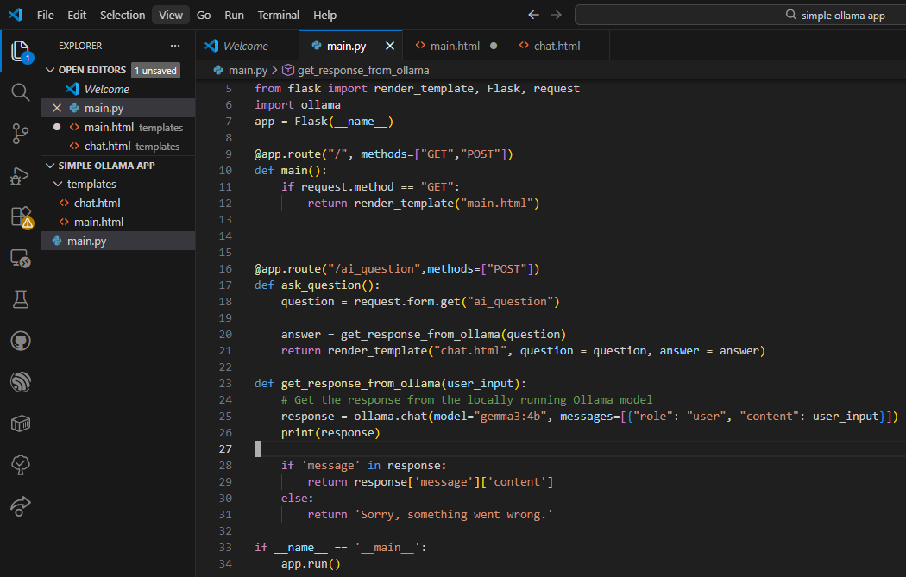  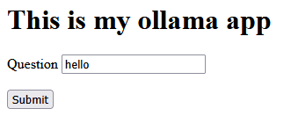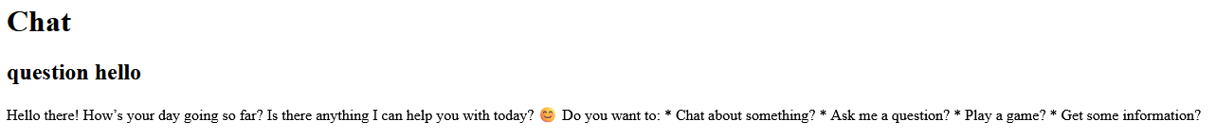
Logbook Entry: | Progress since the last entry: made a whole basic flask app  Task Achieved: This is just to gain familiarity with flask and HTML. Maybe the code will be reusable later in the project.  Stumbling blocks or issues encountered and how they were managed: I had a form tag in the wrong spot.  Possible approaches for upcoming tasks: N/A  Reflective comments: This was a great learning experience but I might have to use a bigger computer or cloud compute if I am to have lots of users
Resources: | https://www.w3schools.com/tags/tag_form.asp  https://www.codewithfaraz.com/python/112/how-to-create-your-own-ai-chatbot-like-deepseek-with-ollama-in-python-flask

Date: | Jan 24, 2026
Title: | Start work on the esp32 server and its architecture
Author: | Freddy Gaffey
Tasks Description: | Made pseudocode for the server architecture  Make a it create a wifi ap and also connect to home wifi  Init platform io
Image: | 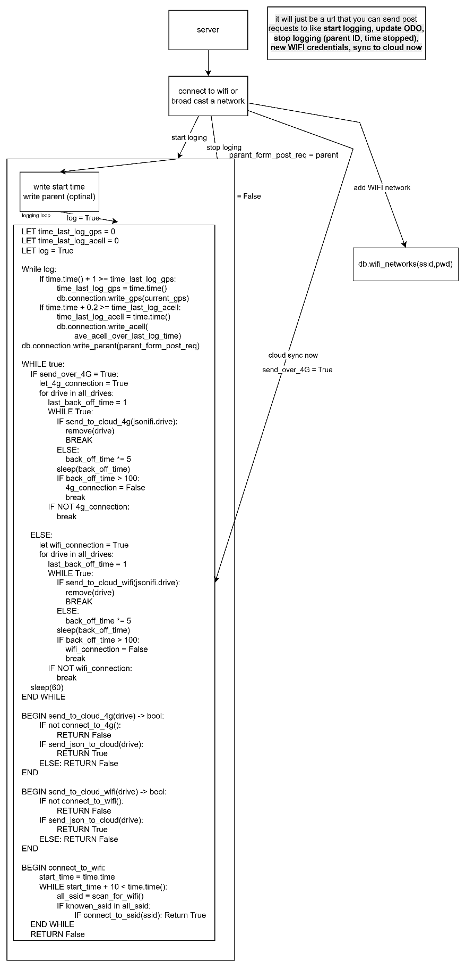
Logbook Entry: | Progress since the last entry: The progress the last entry was that I got a working ESP 32 to connect to Wi-Fi networks and I also worked out the overall system architecture of how the ESP 32 will work  Task Achieved:  got platform IO setup  worked out the architecture of the ESP 32 system  got the ESP 32 connect to Wi-Fi networks and start a simple web server  Stumbling blocks or issues encountered and how they were managed:  Initially I was intending to use Arduino but as we know takes so long to compile and doesn't have the most enjoyable developer experience so halfway through I switched to platform IO and that led to faster compile times better auto completion and because platform IO is a VS code extension it was much more familiar  Possible approaches for upcoming tasks:  I think I'd want to move a lot of the Wi-Fi stuff to a separate folder and then I can have multiple sort of utility files for Wi-Fi SD card GPS etc and then what I can do is in the main file I could just call them and I might also set up a separate file for logging  Reflective comments:  This is my first time writing C++ code properly so it was a bit of a learning curve but there was lots of very good examples online and I also got AI to help me debug my code although because I was learning C++ I made a particular effort not to copy any code directly from anywhere I would always type it out myself so that I would start building the muscle memory.
Resources: | https://github.com/me-no-dev/ESPAsyncWebServer/wiki  https://www.arduino.cc/reference/en/libraries/wifi/  https://www.claude.com/ I asked lots of questions about how to get pointers to work how variable initialisation works how does inheritance in classes work and types and casting and other stuff like that. Also I sometimes used it to translate the C++ code into Python code so it would be easier for me to understand it

Date: | Jan 28, 2026
Title: | Started implementing logging and the fsm which is how it works
Author: | Freddy Gaffey
Tasks Description: | Start to define the state machine architecture  make mocks for the sensors
Image: | 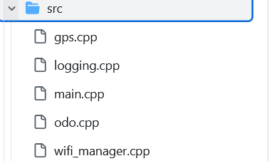  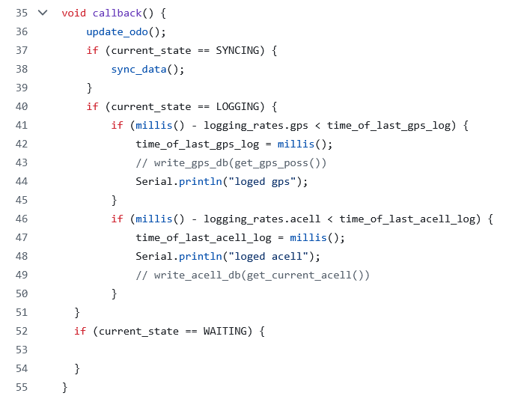  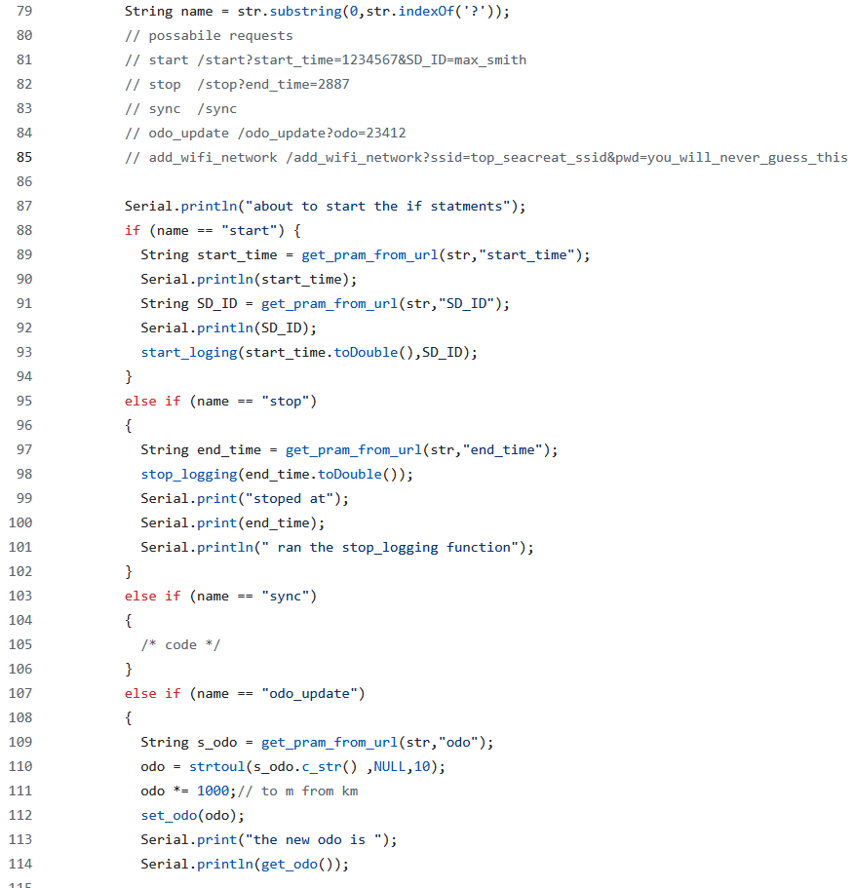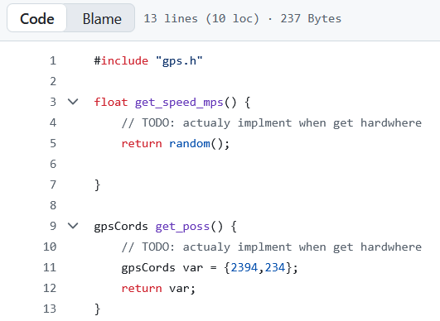
Logbook Entry: | Progress since the last entry:  Implemented more of the state machine architecture as well as defining some mocks also worked out the API endpoint for the server and because of the way I designed it I also developed a parser for passing the URLs into strings so that it would be a convenience function  Task Achieved:  implemented substantially more the finite state machine  did some URL passing and worked on the API endpoints on the server  split things up into different files to make finding code easier and to improve readability  Stumbling blocks or issues encountered and how they were managed:  I didn't know what a .h file was and this is an important file which basically allows you to import code from another file and you need to have this but I didn't know that they were needed so I was trying to import C++ code and getting errors.  It took me a couple attempts to arrive on the callback architecture that I am currently using  Possible approaches for upcoming tasks:  I will need to get some actual hardware so that I can read from So that I can replace my mocks with actual hardware  also I need to working out a significant problem about how to deal with the limitations on browsers unable to let you go from a HTTPS but send a request to an HTTP endpoint.  Reflective comments:  I'm at the point where I've written about 300 to 400 lines of C++ code and I'm finally getting the hang of it is such a different language to Python but I kind of like it
Resources:

Date: | Commits on Jan 29, 2026
Title: | Working out how to get around the HTTPS to HTTP restrictions
Author: | Freddy Gaffey
Tasks Description: | work out how to get around the HTTPS to HTTP restrictions
Image: | There was not much research for this I just spent a lot of time working out trying how to bypass it and every time I had an idea I would use a ai to Fact Check it and to point out the holes in it. Initially I attempted to use CORS but I found out that that would not work because it was being blocked at a lower level.  Then I had the idea of using image tags to essentially request an image from the server and that request could be logged as a starter stop depending on if it requested the start image or stop image this approach is also very hacky and I didn't like it  I also looked in to self signing but it was painful and also a bad UX  I finally decided to use a redirect which lets me Send the user to a site and give them a post request and then I could either let the ESP host the website that has the functionality for logging or I could have it immediately redirected back to the main server and I can also pass in parameters in map post request. But either one of these approaches was feasible and I did not have to now integrate 4G into the L plate have the server sender request to it to start logging and stopping this also gives me offline functionality  Then I used ngrok To host a basic flask PWA I did not write this one myself cause it was not my project I just wanted to validate that PWA way hosted via HTTPS could send a redirect to http website on a local network and it could.  The app code is at 85530ddd3099afc55b22ca76afbb071c9029acae  The esp 32 code is at dbb784d0ca424ba391ff5f7d928fd00ea894bb2d
Logbook Entry: | Progress since the last entry:  I successfully validated one of the fundamental principles of how my project will work.  Task Achieved:  I managed to send redirect from a cloud hosted HTTPS PWA to a locally hosted HTTP server running on the ESP 32 then the ESP 32 was able to redirect back to the cloud-hosted PWA website wow disconnected from the server.  Stumbling blocks or issues encountered and how they were managed:  I mentioned them in the image box  Possible approaches for upcoming tasks:  There is 2 approaches to how I could handle the control of the I could either have the ESP 32 host the UI for start and stop. Or I can have the PWA contain the UI controlling logging and have the PWA redirect the user to the ESP in the ESP redirect back to PWA as fast as possible.  Reflective comments:  I WISH I COULD JUST SEND A GET REQUEST!!! This I absolutely ridiculous
Resources: | https://blog.appmysite.com/what-is-a-progressive-web-app/  https://www.youtube.com/watch?v=wQgx5Pou44s  https://web.dev/learn/pwa  https://hnpwa.com/  https://developer.mozilla.org/en-US/docs/Web/Progressive_web_apps/Tutorials  https://www.youtube.com/watch?v=sFsRylCQblw Progressive Web Apps in 100 Seconds // Build a PWA from Scratch : Fireship  https://developer.chrome.com/docs/workbox/  https://github.com/elegantapp/pwa-asset-generator  HOW TO COMMUNICATE TO THE ESP 32  https://stackoverflow.com/questions/53211319/how-can-i-make-an-http-request-from-an-https-website my fist idea was to have the esp 32 host a server that acts as a API endpoint but this can’t work because mixed content (having https and http) is unsafe so I need to find a way around that.

Date: | Jan 30, 2026
Title: | Writing a SD card in GPS hardware mock
Author: | Freddy Gaffey
Tasks Description: | I made a separate file for a SD card which would basically let me pass in a GPS instance and a speed and it would write to the current SD card log file the GPS data and time
Image: | 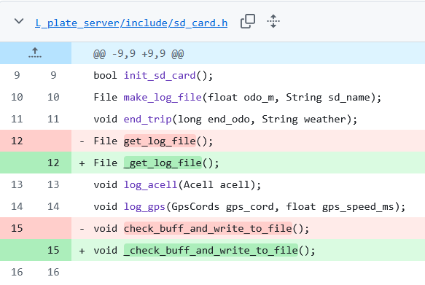  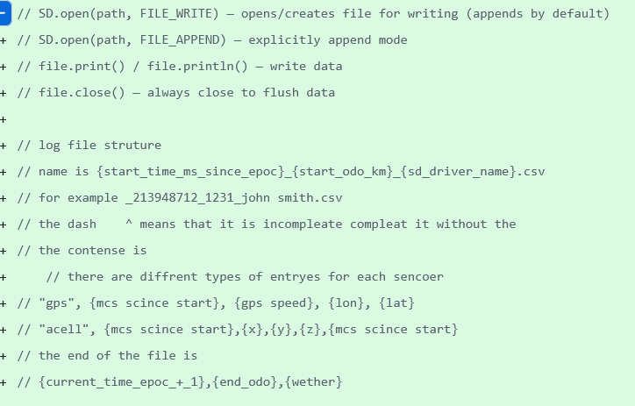  This ^^^ is the log file structure  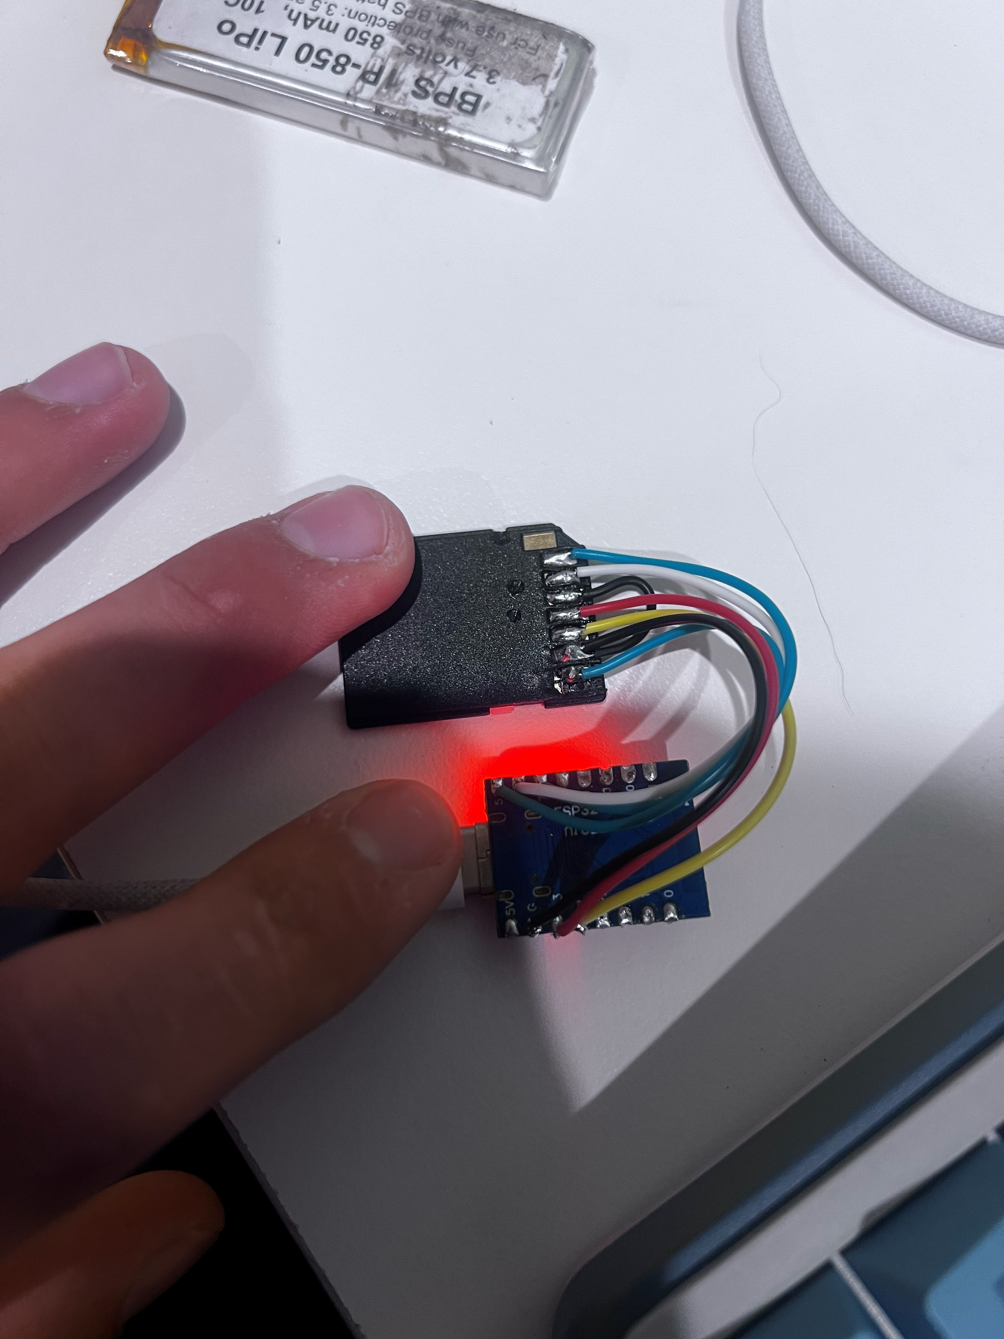  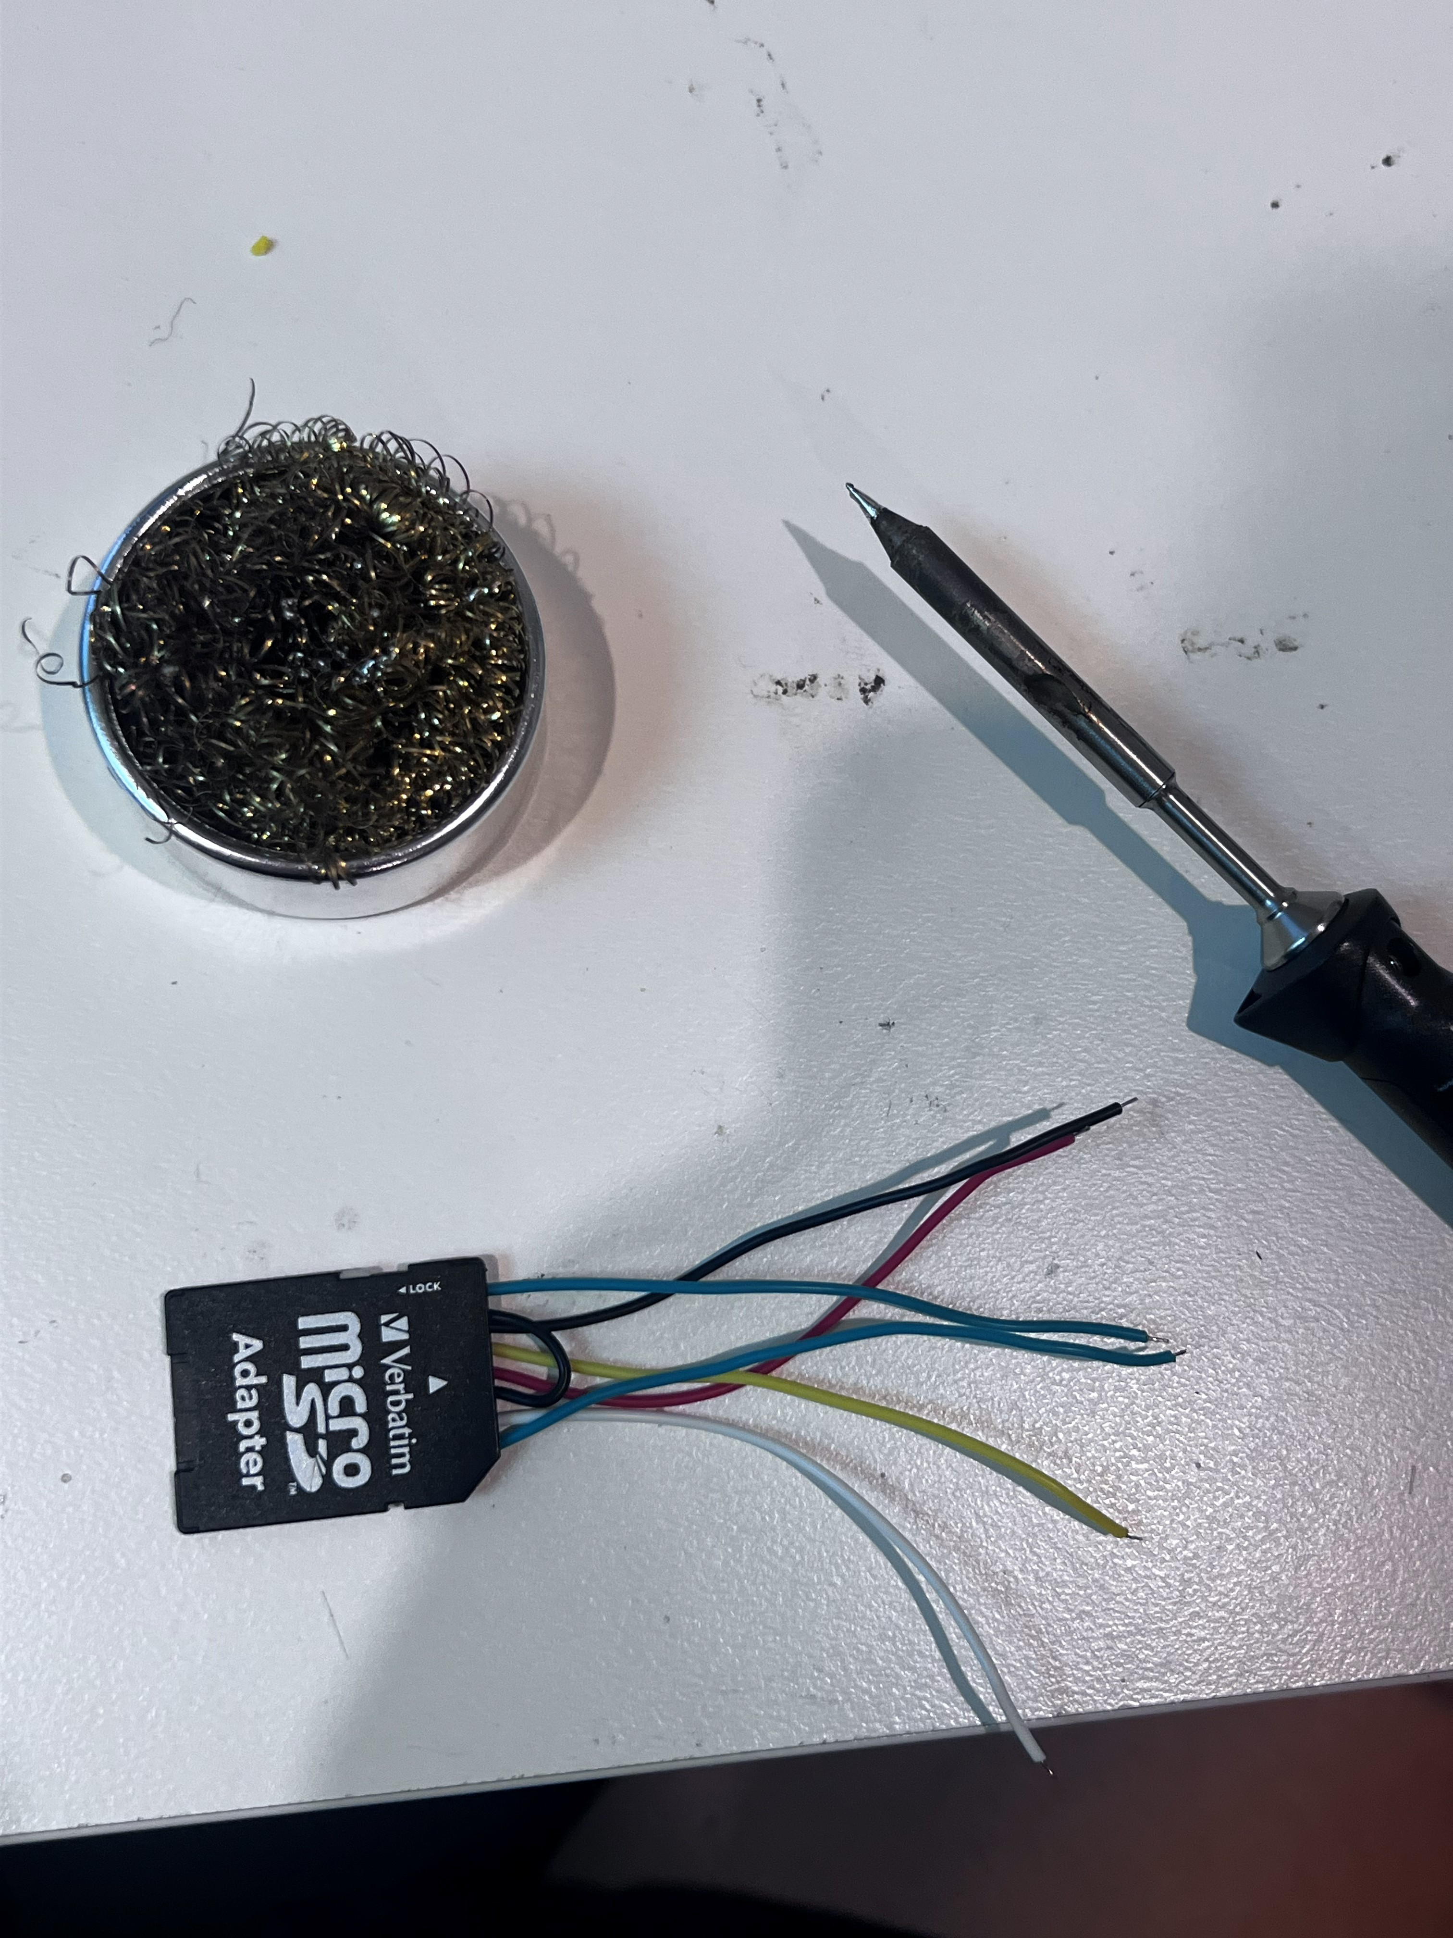
Logbook Entry: | Progress since the last entry:  I designed a log file format  Make some of high level functions such as logging data starting trips ending trips  Task Achieved:  Making high level functions for updating the log files as well as I fix some minor bugs in the Wi-Fi class  I also connected a SD card too my ESP 32  Stumbling blocks or issues encountered and how they were managed:  this file took me a couple of attempts to write because I initially had the wrong approach and I was passing files too much and this had bad performance as this is only running on a small microcontroller so I instead implemented the buffer system where I write to a buffer in memory and then once that buffer overflows (not a buffer overflow it's a string type so it can be written to past a certain point) I will cash it to the SD card.  Possible approaches for upcoming tasks:  I need to check that the rest of this class has enough performance to run at a 10 HZ if needed.  Reflective comments:  Designing a my own csv was fun but passing it will not be have fun future me
Resources: | https://github.com/espressif/arduino-esp32/blob/master/libraries/SD/README.md this was really helpful  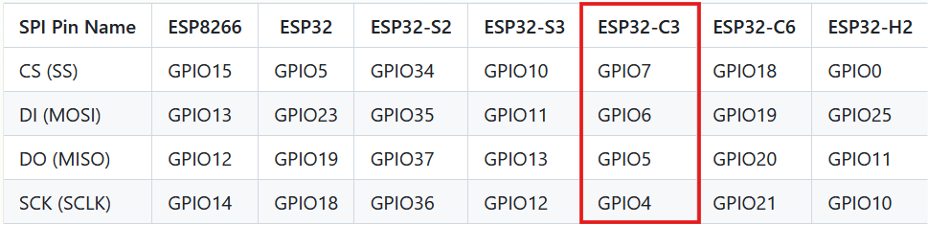  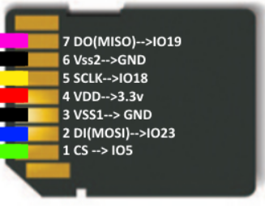

Date: | Jan 31, 2026
Title: | Setting up host name and bug fixes
Author: | Freddy Gaffey
Tasks Description: | Conduct testing on whether the logging actually works and resolve any of those bugs that occur.  Setup host name so that it can be redirected is easier
Image: | 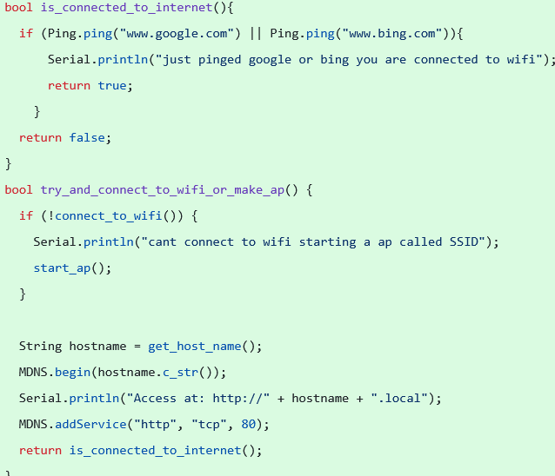  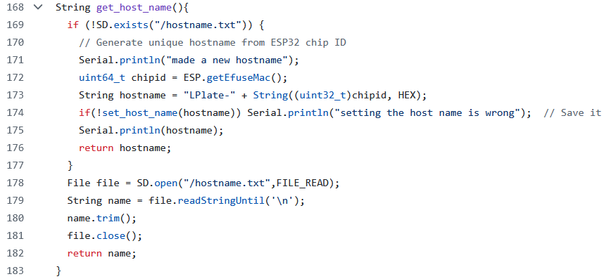  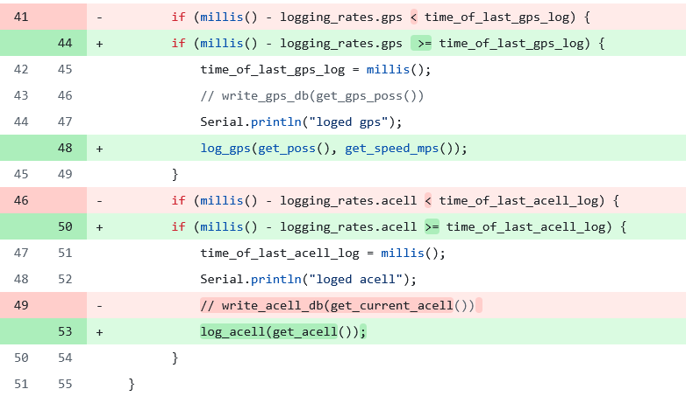  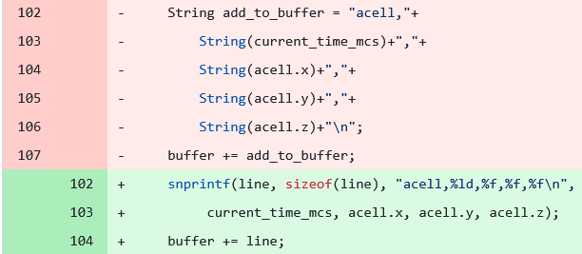  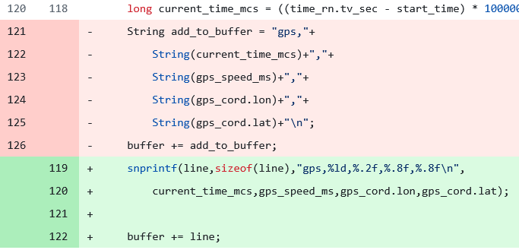  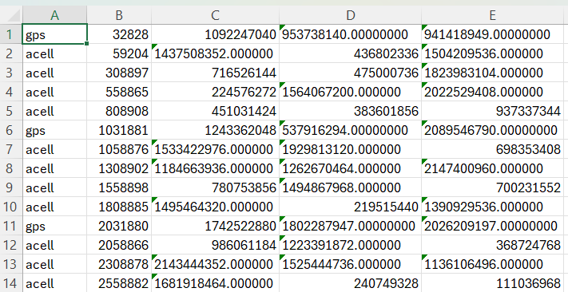  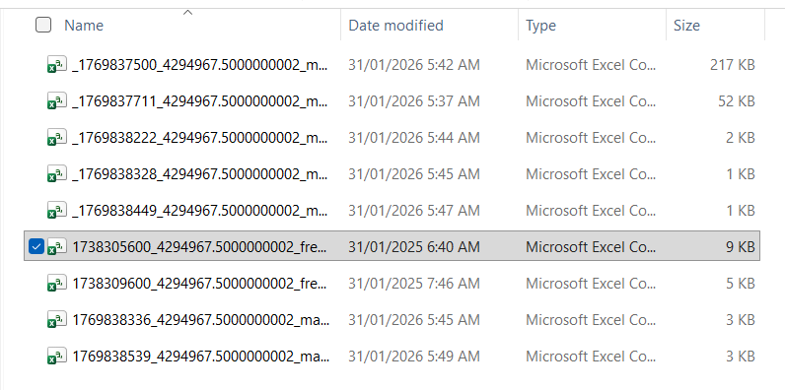  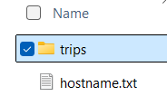
Logbook Entry: | Progress since the last entry:  Implemented checks see if connected to the internet  Made host name configurable by the user by editing the SD card  Bug fixes  Task Achieved:  Have a working host name  Check if connected to the internet by pinging Google.  I used snprintf instead of creating mutable string objects and then concatenating them as it was significantly slowing down performance but now let me run the loop.  Also I fixed some logical errors in logging rate  The L plates logging functions work now  Stumbling blocks or issues encountered and how they were managed:  I Initially had some quite bad performance issues but I fixed them by using more low level memory allocation as well as caching then writing in one go  Possible approaches for upcoming tasks:  I need to determine whether I will have a esp based controller or a play PWA based controller  Reflective comments:
Resources:

Date: | Jan 31, 2026
Title: | Start the main PWA
Author: | Freddy Gaffey
Tasks Description: | imported the code from ed stem  defined my database schema
Image: | 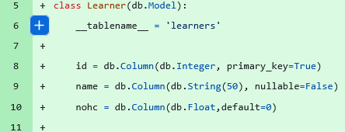  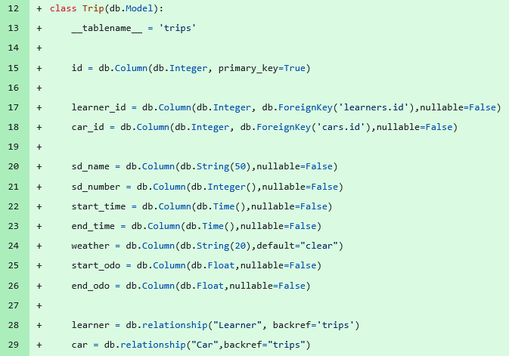  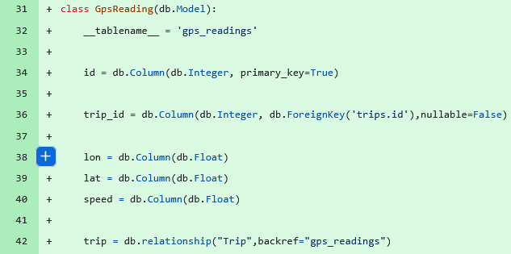  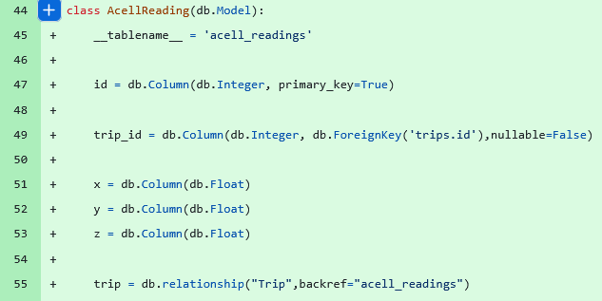  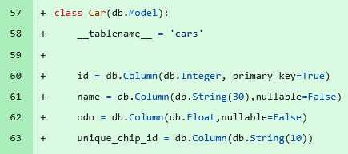  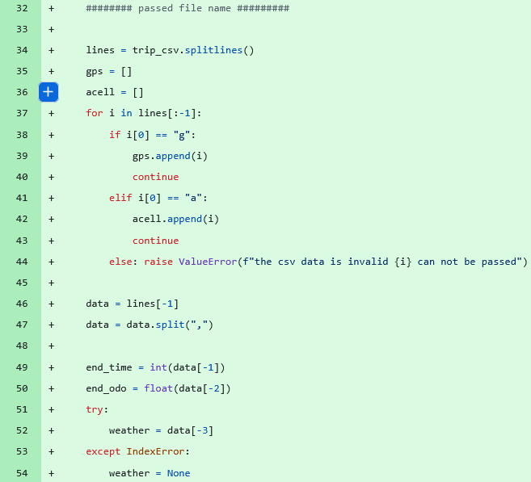  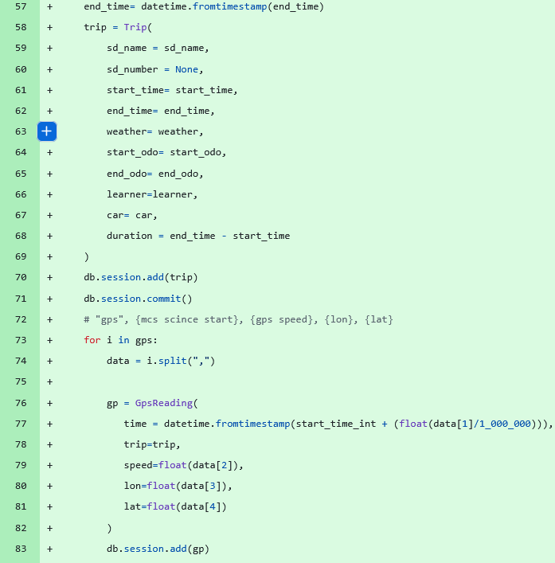  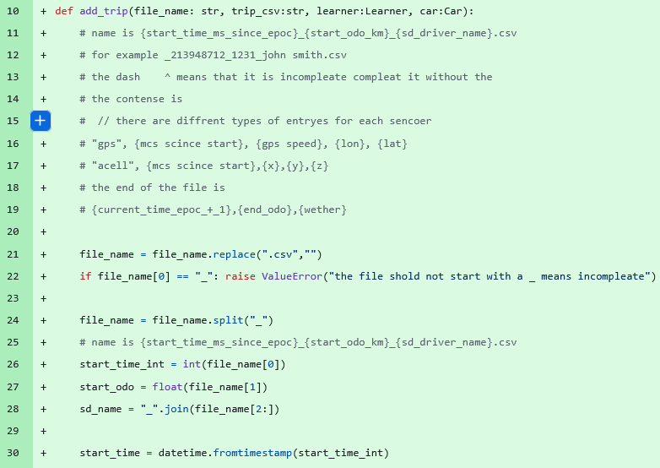  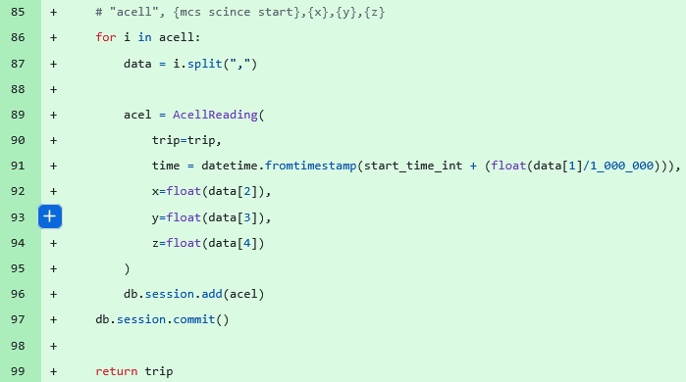
Logbook Entry: | Progress since the last entry:  I've started my a real proper PWA this is no longer just a little test at the time intending to work on for the rest of the project  I have started defining my database schema  made a parser for CSV files to database objects  Task Achieved:  define a database schema in SQL alchemy  I made a way of taking a CSV file and a learn object as well as a title of the file and a car that's all information that will be provided in a get request from the ESP when uploading the trip to be sent to the SQL database. This is not the clearest implementation of a passer but it is good enough and because it is a black box function I can always update it later if it is a bottleneck  Stumbling blocks or issues encountered and how they were managed:  semi colons they're crazy for the first 50 lines I kept on putting in semi colon's everywhere because I was writing in CPP before But then switching over to Python which does not need semi colons it was quite jarring also some of the syntax took a while I kept on trying to define strings with strings at the beginning. Also some of the iteration got a little bit complicated with the exact implementation of the Python methods because it had been a couple of weeks since I've used him and I had to Google to check the exact inputs for example these split lines and the split functions I thought then modified the data instead of returning it  Also converting from epoch time to a datetime object was a bit tricky  Possible approaches for upcoming tasks:  I need to define a user class that will be created when the user logs in I also need to do AI features and start writing some HTML and also do some diagrams to work out what I want the layout of this website to look like  Reflective comments:
Resources: | it was mostly the code that was existing on the Ed stamp and I just modified it for my needs as well as some for how to do foreign keys  https://www.geeksforgeeks.org/python/sqlalchemy-core-multiple-tables/

Date:
Title:
Author:
Tasks Description:
Image:
Logbook Entry: | Progress since the last entry:  Task Achieved:  Stumbling blocks or issues encountered and how they were managed:  Possible approaches for upcoming tasks:  Reflective comments:
Resources:

Date: | 2/2/2026
Title: | Work out how to integrate ai advanced future
Author: | Freddy Gaffey
Tasks Description: | Find ai platform that lets me have models with custom context and generate the context
Image: | 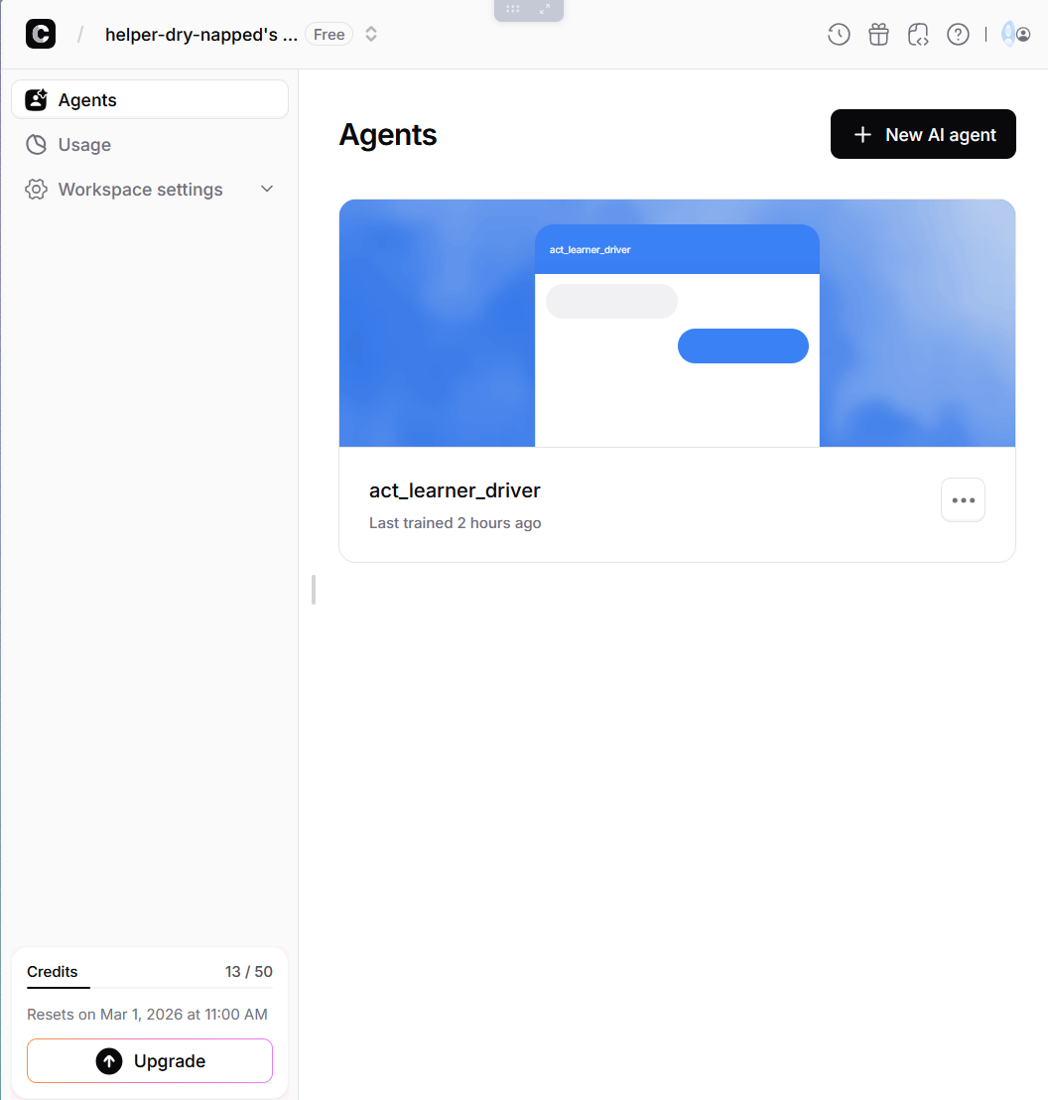  I also go to Claud to make a template for generating the rag document then I got it to make the actual RAG documents the prompts and the code the git repo as it is to long to put here
Logbook Entry: | Progress since the last entry:  Task Achieved:  Stumbling blocks or issues encountered and how they were managed:  Possible approaches for upcoming tasks:  Reflective comments:
Resources:

Date: | 3/2/2026
Title: | Work out how to bypass https to http again
Author: | Freddy Gaffey
Tasks Description: | Make a story board to help work out what the server should to and the esp 32
Image: | 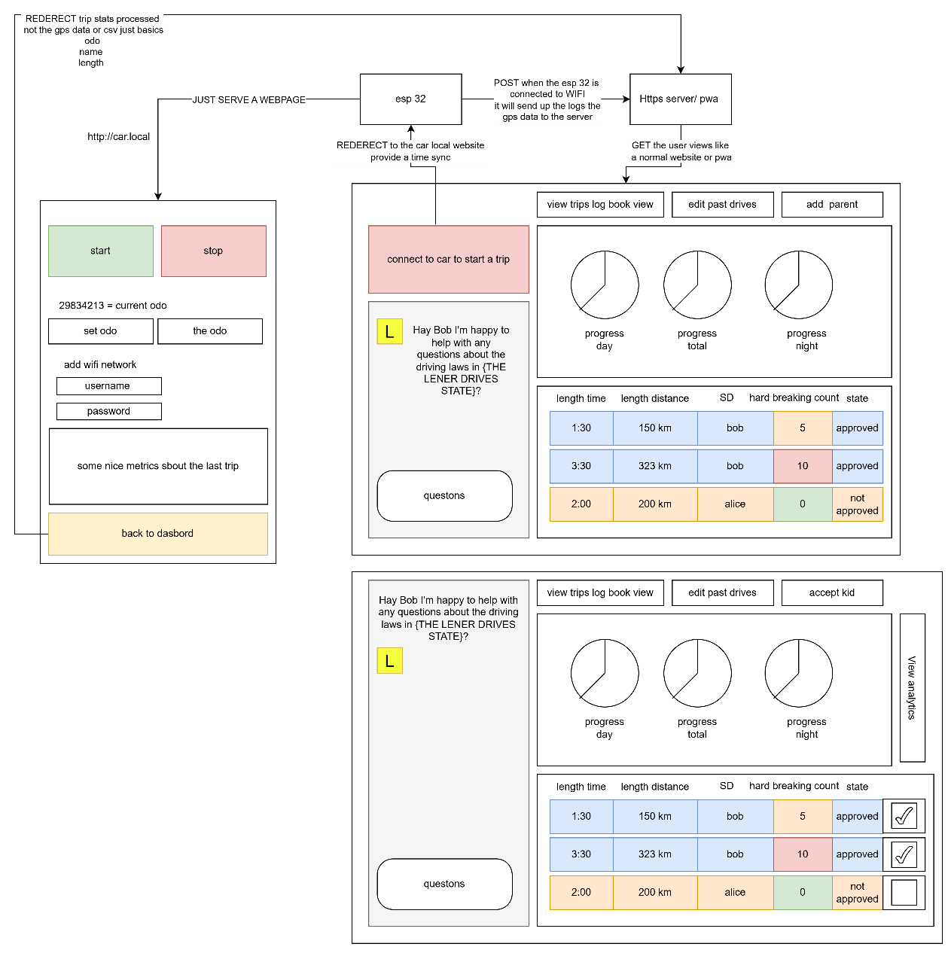
Logbook Entry: | Progress since the last entry:  I made the beginnings of a story bord and also I decided to have the drive controller to be on the hosted on the esp 32  Task Achieved:  Stumbling blocks or issues encountered and how they were managed:  It was fairly easy, I had already given this a great amount to thought  Possible approaches for upcoming tasks:  See above  Reflective comments:  YES I finally worked it out for real this time
Resources:

Date: | 21/2/2026
Title: | Change to Capacitor from PWA
Author: | Freddy Gaffey
Tasks Description: | Did research on native apps and decided to switch as Bluetooth has no support for PWAs on iso so I was doing a really janky approach with redirects and wifi but I will now use a Capacitor native runtime that is cross-platform.  Then after that I have meeting with my old IT teacher from Canberra grammar school we discussed. XXXXXXXXX put in the email XXXXXXXX  I made a vibe coded app to test out ui as a prototype I will use this to help me make ui improvements and also to as an example for when I make it my self this also lets me look at different architectures and evaluate the best one for me.
Image:
Logbook Entry: | Progress since the last entry:  Switched to capacitor  Vibe coded a prototype  Task Achieved:  Just research and design work no features completed  Stumbling blocks or issues encountered and how they were managed:  Not that much I stat down with my old IT teacher for 4 hours to work these things out  Possible approaches for upcoming tasks:  s  Reflective comments:
Resources:

Date:
Title: | Made a vibe coded app to evaluate architecture and UI
Author:
Tasks Description:
Image:
Logbook Entry: | Progress since the last entry:  Task Achieved:  Stumbling blocks or issues encountered and how they were managed:  Possible approaches for upcoming tasks:  Reflective comments:
Resources:

Date: | 23/2/26
Title: | Designed how to trip and dashboard work
Author: | Freddy Gaffey
Tasks Description: | Design the trip to work better
Image: | 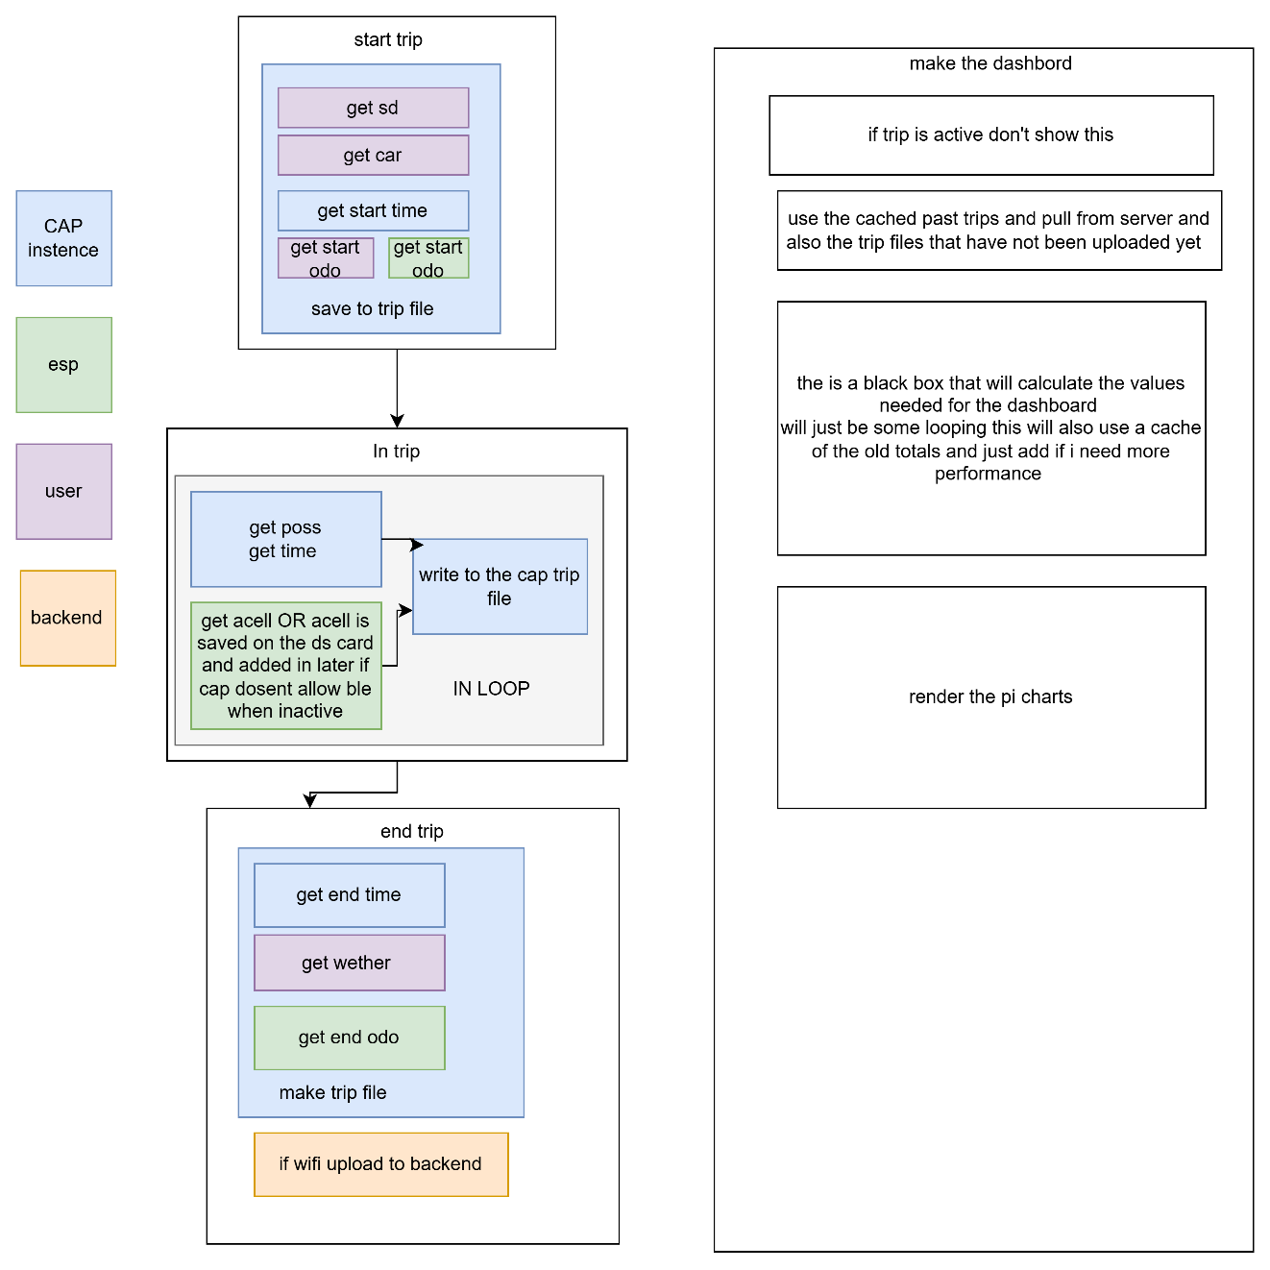
Logbook Entry: | Progress since the last entry:  Did some design work  Task Achieved:  Got a preliminary on the trip design  Stumbling blocks or issues encountered and how they were managed:  Nill  Possible approaches for upcoming tasks:  See above  Reflective comments:  I am felling confidant
Resources: | My brain

Date: | 28/2/2046
Title: | Made up prototypes with a ai agent
Author: | Freddy Gaffey
Tasks Description: | Made some UI prototypes to do market research  I used a ai Claude to make a app with all the fetures then I asked it to make me a prompt to generate mor app like that and to add the the propt to make the app different and through that prosses I got the following prompt that I used to make this app that you will see here  “””L-Plate Logger — UI Prototype Generator Prompt  You are designing a UI prototype for L-Plate Logger, an Australian learner driver hours tracking app. This is a UI prototype only — all data is mocked, there is no backend. The purpose is to explore innovative and visually distinct interface designs for market research, so each time this prompt is used, produce a completely different visual style, layout, colour scheme, typography, and interaction pattern. Be creative and experimental — try unconventional layouts, bold aesthetics, and novel interaction ideas. The goal is to generate a range of diverse prototypes that can be shown to potential users to gauge preferences.  Output a single self-contained HTML file with inline CSS and JavaScript. It must work on mobile (optimised for small screens) and desktop.  App Overview  An app that helps NSW learner drivers track their 120 required supervised driving hours (including 20 night hours) needed to obtain a P1 licence. The app logs trips, tracks progress, lets parents/supervisors approve trips, and includes an AI chatbot for road rules questions.  Required Features  Authentication  A login screen and a registration screen (or combined)  Registration collects: first name, last name, email, password, account type (Learner Driver or Parent/Supervisor), and Australian state  Password must be minimum 8 characters  Validate all fields and show error messages for invalid input  Include a demo/quick-login button for fast access  A mock user database with at least one pre-existing learner account and one parent account  Session persistence within the tab so refreshing stays logged in  Sign out functionality that returns to the login screen  Trip Logger  The primary screen of the app — this is what users see most  A start/stop trip recording control that is immediately accessible on mobile without scrolling — this is the most critical interaction  Before starting a trip, the user must select a vehicle and a supervising driver  The user can tag driving conditions before or during a trip (rain, night, city, highway, school zone, rural)  While a trip is recording, display live mock data: current speed, distance travelled, elapsed time, harsh braking count  Show mock phone GPS coordinates and accuracy during recording  Display overall progress toward the 120 hour requirement, broken down into day hours and night hours (20h night minimum)  Trip History  A scrollable list of past mock trips  Each trip shows: date, time, duration, distance, supervising driver, vehicle, conditions, and approval status (approved or pending)  Tapping a trip shows more detail  Ability to filter trips (by status, by night driving, etc.)  Visual charts (pie/donut) summarising trip data broken down by:  Day vs night hours  Driving conditions  Supervising driver  Vehicle  Approval status  Road Rules AI Chatbot  A chat interface where users can ask questions about NSW learner driving laws  Pre-populated suggested questions the user can tap  Mock AI responses for at least these topics: hours required for P1, night driving rules, speed limits for learners, logbook requirements  A default response for any other question  Show a typing/thinking indicator before responses appear  Support basic text formatting in responses (bold text)  Settings  Display the logged-in user's profile (avatar/initials, name, account type, state)  A working light/dark theme toggle that persists  Menu items for: Profile, Supervisors, Parent Access, Phone GPS, Location Accuracy, Logger Defaults, Export Logbook  All of these menu items show a message: "This feature has not been implemented as it is a demo"  Sign out button  General Requirements  Mobile-first responsive design that also works on desktop  Toast/snackbar notifications for user feedback on actions  Navigation between all sections of the app  All data is mocked with realistic Australian learner driver data  Light and dark mode support  Mock Data to Include  Users  A learner driver account (any name, email: demo@lplate.app, password: password123, state: NSW)  A parent/supervisor account (any name, email: parent@lplate.app, password: password123, state: NSW)  Trips (at least 7)  Include a mix of:  Day and night trips  Different supervisors (at least 2)  Different vehicles (at least 2)  Approved and pending statuses  Various conditions (highway, city, rain, night, rural, school zone)  Durations ranging from 30 minutes to 2+ hours  Realistic distances for the duration  Progress  Total hours logged should be roughly 50-70 hours out of 120  Night hours should be roughly 10-15 out of 20 required  Show this as a percentage and breakdown  AI Chatbot Responses  Provide accurate mock responses based on NSW road rules:  120 hours total required, 20 must be at night  Must hold learner licence for 12 months minimum  Maximum speed of 90 km/h regardless of posted limit  Must display L-plates front and rear  Zero blood alcohol concentration  Must be accompanied by a fully licensed driver at all times  Supervising driver must have held unrestricted licence for 1+ year  Log book must record: date, start/end times, duration, odometer readings, day/night, supervisor name and signature, road conditions  Important Notes  This is a UI prototype for market research — prioritise visual design and interaction quality  Try a completely different aesthetic direction each time — different colours, fonts, layouts, navigation patterns, animation styles  Explore innovative approaches: gesture-based interactions, card-based layouts, dashboard styles, map-centric views, gamification elements, minimalist designs, skeuomorphic designs, etc.  The start trip button must always be reachable without scrolling on a small mobile screen  Do not use the name "Fred" anywhere in the app  All settings features (except theme toggle and sign out) should show the demo not-implemented message”””  So I ran this 5 times and got the following apps  I also make a new repo as my old one was to terrible so disorganized like 100 branches nothing committed to main gitignore was never set up properly and I have to basically restart anyway now  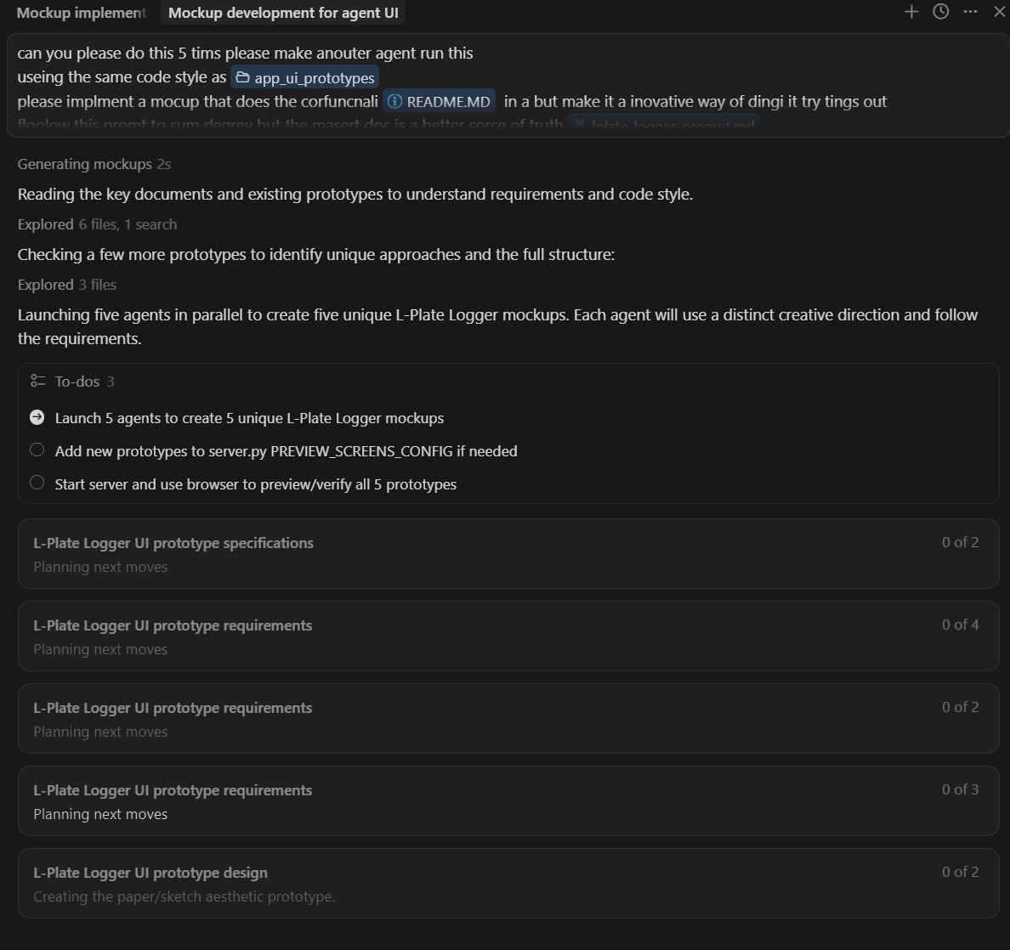  Look I know how to use agents
Image: | 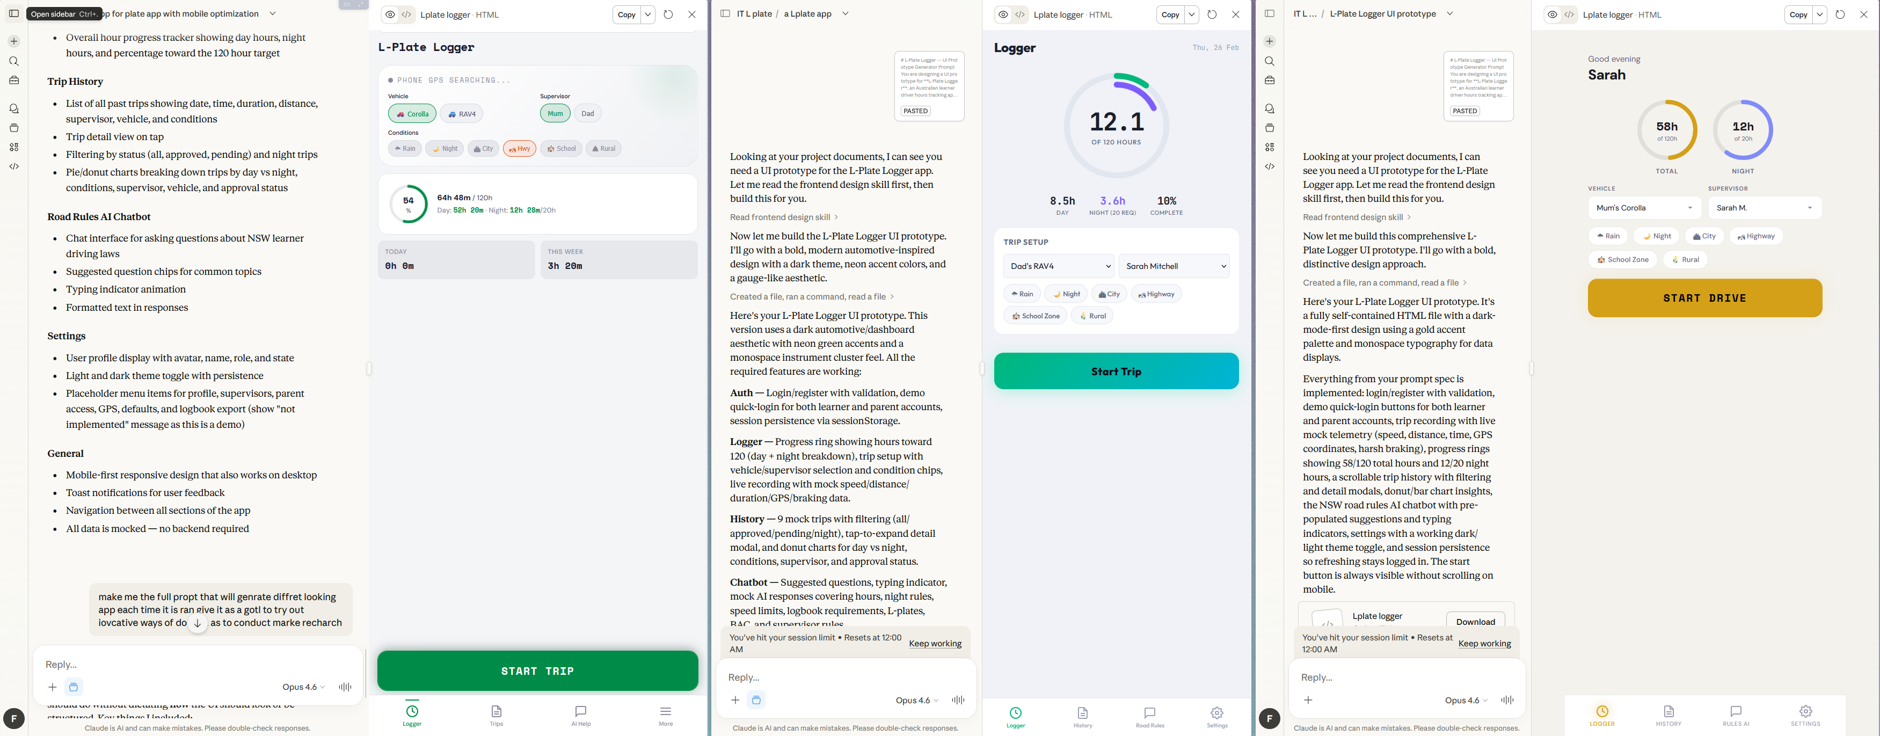  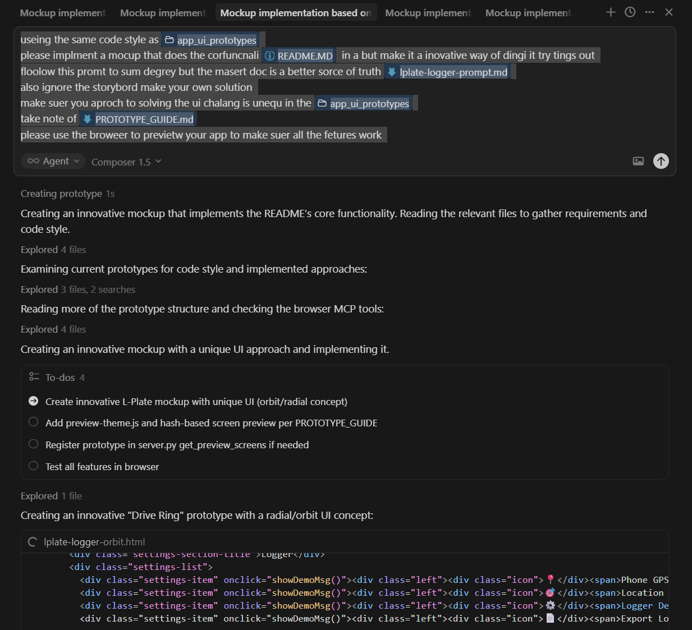  I also made a server to preview the application so that I user can use view them all  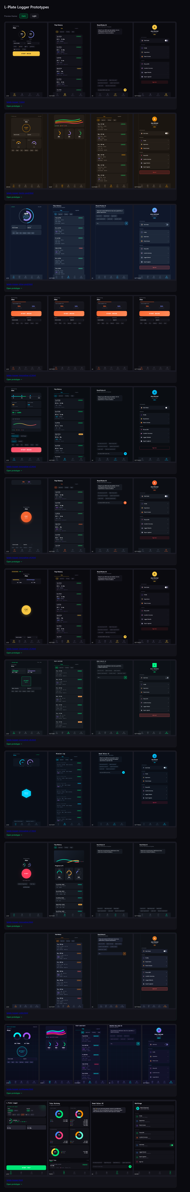  
Logbook Entry: | Progress since the last entry:  Task Achieved:  Stumbling blocks or issues encountered and how they were managed:  Possible approaches for upcoming tasks:  Reflective comments:
Resources:

Date: | 1-4/3/2026
Title: | Finally got auth to work
Author: | Freddy GaffeyCommits:  0a96bf5 · 2026-03-01 · made the db kina need to add inits and made some utils  f959357 · 2026-03-01 · add input validation on user  317edc5 · 2026-03-01 · add validation reorder for readblity  99f5998 · 2026-03-01 · remove user name as it just complicates things  cde1b88 · 2026-03-01 · make login work  dd27924 · 2026-03-02 · add the backend functionaliy for auth  db0b14d · 2026-03-04 · finaly got auth to work!!!
Tasks Description: | AI TEXT REMOVED  I finally got authentication working end to end. I built out the SQLAlchemy models for things like User and LicenseInfo, then wrote a bunch of input validation helpers for the password, email, licence number, state and date of birth. After that I wired up registration and login using JWT tokens, and added a require_auth decorator so I can lock down any routes that need a logged-in user.
Image: | backend/my_auth.py  def require_auth(f):  @wraps(f)  def decorated(*args, **kwargs):  token = request.cookies.get('auth_token')  auth_header = request.headers.get('Authorization')  if not token and auth_header and auth_header.startswith('Bearer '):  token = auth_header.split(' ')[1]  if not token:  return jsonify({"message": "unauthorized"}), 401  try:  payload = jwt.decode(token, secret_key, algorithms=['HS256'])  request.user_id = payload['sub']  return f(*args, **kwargs)  except jwt.InvalidTokenError as e:  return jsonify({"message": "invalid token"}), 401  return decorated
Logbook Entry: | Progress since the last entry:  Task Achieved:  Stumbling blocks or issues encountered and how they were managed:  Possible approaches for upcoming tasks:  Reflective comments:
Resources:

Date: | 11-12/4/2026
Title: | Ported app to Capacitor for iOS, got GPS/login/trips working
Author: | Freddy GaffeyCommits:  3859aca · 2026-04-11 · made blank routes and tab navigation  0c799d0 · 2026-04-11 · i got it to run on a ios simuation also slight refactor of the pages to work on ios  2214a8a · 2026-04-11 · got location data manule poling working  e208cee · 2026-04-11 · make rediects work on ios NOTE: ai asseted fix  3c4cbb1 · 2026-04-11 · make cocieys work on ios  04c51bd · 2026-04-11 · get location working on real phone using public prot fowading  831bea0 · 2026-04-12 · added signout added loging added end trip saving trips will now read poss without bugs added ai chat bot (this was just a i frame)  af1bc22 · 2026-04-12 · add manule odo ai asseted wether api intergarton and auto day night detection
Tasks Description: | AI TEXT REMOVED  I ported the app over to Capacitor and got it running on both the iOS simulator and a real phone, using public port forwarding so the GPS would work. There were some annoying cookie and redirect issues that only showed up on iOS, so I sorted those out, then got sign-out, login and end-trip saving with GPS data all working. I also dropped in a first version of the AI chatbot (just an iframe at this stage), and added manual odometer entry, weather API integration and automatic day/night detection.
Image: | src/router/index.ts  // example placeholder — replace with the actual ios cookie/redirect fix snippet  router.beforeEach(async (to, from) => {  const isAuth = await checkAuth()  if (!isAuth && to.meta.requiresAuth) return '/login'  })
Logbook Entry: | Progress since the last entry:  Task Achieved:  Stumbling blocks or issues encountered and how they were managed:  Possible approaches for upcoming tasks:  Reflective comments:
Resources:

Date: | 14-19/4/2026
Title: | Got trip history pulling/displaying and pie charts working
Author: | Freddy GaffeyCommits:  518dbd8 · 2026-04-14 · got trips to be pulled and displayed  9c378f1 · 2026-04-17 · the pi charts are working the navigation now works and added some debug tools in settings  b10da69 · 2026-04-17 · got the pi chats to work with diffrent states hours
Tasks Description: | AI TEXT REMOVED  I got trips pulling back from the backend and showing up properly in the trip history. I also added pie charts for day, night and total hours progress, and made sure they respect each state's different hour requirements. On top of that I fixed up the navigation and added some debug tools into the settings page.
Image: | src/views/dashboard.vue  <Pie :data="DchartData" :options="DchartOptions"/><p>{{ totalDay }}/{{ capDay }}</p>  <Pie :data="NchartData" :options="NchartOptions"/><p>{{ totalNight }}/{{ capNight }}</p>  <Pie :data="TchartData" :options="TchartOptions"/><p>{{ total }}/{{ capTotal }}</p>  const DchartData = ref({ datasets: [{ data: [0, 90], backgroundColor: ['#C5BF10', '#E0E0E0'] }] })  const DchartOptions = { responsive: true, plugins: { title: { display: true, text: 'Day Hours' } } }
Logbook Entry: | Progress since the last entry:  Task Achieved:  Stumbling blocks or issues encountered and how they were managed:  Possible approaches for upcoming tasks:  Reflective comments:
Resources:

Date: | 19-28/4/2026
Title: | Built out Cars, Sv (supervising drivers) and trip cards
Author: | Freddy GaffeyCommits:  6783fc2 · 2026-04-19 · deleate get post for the bacend also add buttone to settings got te sync work flow working  ad9d5ed · 2026-04-19 · move settings to debug and make new settings get ai to start settings template  5e241b3 · 2026-04-21 · start adding cars still buggy  807d576 · 2026-04-21 · got the cars to get ble id and to deleat (i used a ai genarated file car from modle that did a lot of the heavy lifting  9f81ddb · 2026-04-22 · added better syncing and added sv to settings  94ac5ba · 2026-04-23 · make trip cards this took a bit to fixing things up  b1da215 · 2026-04-23 · start moviving cars trips and svs to classes as easer  2426718 · 2026-04-24 · add a class for cars  5da5ef0 · 2026-04-24 · make the cars work now show on card  6f1ac9a · 2026-04-28 · made a svs class and also got the dasbord working and caught some baced errors
Tasks Description: | AI TEXT REMOVED  I built out car management with BLE device id pairing and deletion, starting from an AI-generated model file as a base. I also added Sv (supervising driver) management in the settings, and refactored Cars, Trips and Sv into proper classes to keep things tidy. After that I built the trip cards on the dashboard and fixed a bunch of backend bugs I ran into along the way.
Image: | backend/data.py  class Car(db.Model):  id = db.Column(db.Integer, primary_key=True, autoincrement=True)  owner_id = db.Column(db.Integer, db.ForeignKey("user.id"), nullable=False)  nickname = db.Column(db.String(100), nullable=False)  plate = db.Column(db.String(20), nullable=True)  ble_device_name = db.Column(db.String(64), nullable=True)  ble_service_uuid = db.Column(db.String(36), nullable=True)  pairing_secret = db.Column(db.String(64), nullable=True)
Logbook Entry: | Progress since the last entry:  Task Achieved:  Stumbling blocks or issues encountered and how they were managed:  Possible approaches for upcoming tasks:  Reflective comments:
Resources:

Date: | 12-15/5/2026
Title: | Guest driver dashboard flow and odometer autofill
Author: | Freddy GaffeyCommits:  3690096 · 2026-05-12 · improve dasbord start funcnity for guest driver  8ceaaf5 · 2026-05-12 · ai asseded rename of nickname in in sv to full_name this is the simpifi the design of the app i can reintrduce later  9f9953b · 2026-05-15 · start odo autofill
Tasks Description: | AI TEXT REMOVED  I improved the dashboard so a guest driver can start a trip without needing a full account. I also renamed nickname to full_name on the Sv model (with a bit of AI help) to simplify the data model, and made a start on auto-filling the odometer reading from the last trip's end value.
Image: | backend/data.py  class Sv(db.Model):  id = db.Column(db.Integer, primary_key=True, autoincrement=True)  owner_id = db.Column(db.Integer, db.ForeignKey("user.id"), nullable=False)  full_name = db.Column(db.String(100), nullable=False)  licence_no = db.Column(db.String(100), nullable=False)

Date: | 20-29/5/2026
Title: | Deployed to production — Cloudflare Pages + VPS systemd service
Author: | Freddy GaffeyCommits:  5931df9 · 2026-05-20 · make cpp test code  41cd2a2 · 2026-05-20 · update to enable production  0b2f25b · 2026-05-20 · add comment  8979b13 · 2026-05-20 · expand .gitignore to cover esp32 .pio cache  699d286 · 2026-05-20 · save  9357ce3 · 2026-05-20 · save  ab61269 · 2026-05-20 · save  51e227d · 2026-05-20 · add wrangler config for cloudflare pages  e11883b · 2026-05-20 · flatten cap_app/ into repo root; drop old prototype and bug-report dirs  fb42176 · 2026-05-20 · save  c407bb4 · 2026-05-21 · add prod url  a34af73 · 2026-05-22 · save  2c73876 · 2026-05-22 · save  46405e2 · 2026-05-22 · make a systemctl file to start server automaticaly in VPS  c7d7062 · 2026-05-22 · make a systemctl file to start server automaticaly in VPS  37d2ab4 · 2026-05-22 · remove the parant ref  cec1ea0 · 2026-05-22 · remove the parant ref  8b867e4 · 2026-05-26 · update the url in production.env to be a subdomain
Tasks Description: | AI TEXT REMOVED  I got the app deployed to production. I set up Cloudflare Pages for the frontend with a Wrangler config, flattened the cap_app/ folder into the repo root and cleared out the old prototypes. I also wrote a systemd service file so the Flask backend auto-starts on the VPS, and fixed up the CORS and production env/subdomain config.
Image: | backend/lflip.service  [Unit]  Description=Lflip Flask backend  After=network.target  [Service]  User=fred  WorkingDirectory=/home/fred/Lflip/backend  ExecStart=/home/fred/venv/bin/python app.py  Restart=always  RestartSec=3  [Install]  WantedBy=multi-user.target
Logbook Entry: | Progress since the last entry:  Task Achieved:  Stumbling blocks or issues encountered and how they were managed:  Possible approaches for upcoming tasks:  Reflective comments:
Resources:

Date: | 30/5/2026
Title: | Restructured backend tables and finished guest-driver frontend
Author: | Freddy GaffeyCommits:  23f19cc · 2026-05-28 · make serve debug on sepret prot  3b8192a · 2026-05-28 · save  ca2e659 · 2026-05-28 · save  64ac1d0 · 2026-05-29 · update cors  bef09ac · 2026-05-29 · save  a6c1386 · 2026-05-30 · update the bacend so that it has a better table structure have a fout end that work for guest drives also make the marketing page popup on ios
Tasks Description: | AI TEXT REMOVED  I reworked the database table structure to be a lot cleaner. I also finished off the guest-driver frontend flow so it's fully working now, and added a marketing popup that shows on iOS.
Image: | backend/data.py  class Trip(db.Model):  id = db.Column(db.Integer, primary_key=True, autoincrement=True)  learner_id = db.Column(db.Integer, db.ForeignKey("user.id"), nullable=True)  start_time = db.Column(db.DateTime, nullable=True)  end_time = db.Column(db.DateTime, nullable=True)  day_night = db.Column(db.String, nullable=True)  sv_id = db.Column(db.Integer, db.ForeignKey("user.id"), nullable=True)  car_id = db.Column(db.Integer, db.ForeignKey("car.id"), nullable=True)  aproved = db.Column(db.Boolean, default=False)
Logbook Entry: | Progress since the last entry:  Task Achieved:  Stumbling blocks or issues encountered and how they were managed:  Possible approaches for upcoming tasks:  Reflective comments:
Resources:

Date: | 1-2/6/2026
Title: | ESP32 ESP-NOW pairing, BLE master, L-plate servo + battery cutoff
Author: | Freddy GaffeyCommits:  b1cb8ce · 2026-06-01 · esp32: ESP-NOW pairing + encrypted comms, BLE master, mock servo  e7e2101 · 2026-06-01 · esp32: add serial-monitor commands (p/r/s) for bench testing without buttons  2fb84ba · 2026-06-01 · app: add L-plate UP/DOWN test buttons to the car edit modal  919ccc8 · 2026-06-01 · plates: per-car BLE link, trip-scoped; master advertises unique LP-<uid>  465a561 · 2026-06-01 · edge: mock servo on D10 (HIGH=open/UP, LOW=closed/DOWN)  4808637 · 2026-06-02 · edge: add battery low-voltage soft-cutoff; servo PWM moves to D10  74ef9fa · 2026-06-02 · debug: BLE master debug panel (pairing control + live edge stats)
Tasks Description: | AI TEXT REMOVED  I built encrypted ESP-NOW pairing between the master board and the edge boards, and added a BLE master with a debug panel showing live edge stats. Each car now links to its own L-plate through a unique BLE id (LP-<uid>), and I added a servo to physically raise and lower the L-plate. I also put in a low-voltage battery cutoff that drops the edge board into deep sleep so the battery doesn't drain any further.
Image: | esp32/src/edge/main.cpp  // EMERGENCY SLEEP: cut servo power + signal, then deep-sleep forever so the  // battery isn't drained further. Needs a manual reset/reflash of normal  // firmware to restore. (Set EMERGENCY_SLEEP 0 to disable.)  #define EMERGENCY_SLEEP 1  #if EMERGENCY_SLEEP  esp_deep_sleep_start();  #endif
Logbook Entry: | Progress since the last entry:  Task Achieved:  Stumbling blocks or issues encountered and how they were managed:  Possible approaches for upcoming tasks:  Reflective comments:
Resources:

Date: | 11-12/6/2026
Title: | Added sanitisation/validation and improved UI styling
Author: | Freddy GaffeyCommits:  ef33b07 · 2026-06-11 · add samitation and data validation  b1f7d5f · 2026-06-12 · added css styling and improved the ui relabeled thing and some small logic things  84f8e24 · 2026-06-12 · Add ESP-NOW edge battery/servo updates and dashboard cleanup
Tasks Description: | AI TEXT REMOVED  I added input sanitisation and data validation across the backend routes to tighten things up. I also improved the CSS styling throughout the app, relabelled some of the UI elements and fixed a few small logic issues while I was in there.
Image: | backend/utils.py  def is_name_valid(name) -> str | None:  if name is None: return None  name = str(name).strip()  if not name or len(name) > 100: return None  if not all(c.isalpha() or c in " '-" for c in name): return None  return name
Logbook Entry: | Progress since the last entry:  Task Achieved:  Stumbling blocks or issues encountered and how they were managed:  Possible approaches for upcoming tasks:  Reflective comments:
Resources:

Date: | 15/6/2026
Title: | Added AI chatbot backend — chat tables, geo lookup, token limits, AI auth server
Author: | Freddy GaffeyCommits:  f2e65c0 · 2026-06-15 · add chat tables, geo remoteness lookup, ai token limits and ai auth server  53d9901 · 2026-06-15 · ad
Tasks Description: | AI TEXT REMOVED  I built out the backend for the AI chatbot. I added Chat and ChatMessage tables to store conversation history, plus a remoteness-area lookup that classifies a GPS point using the ABS API. I also added per-5-hour and per-week token usage limits worked out from the chat log, and built a separate AI auth server that checks those limits, queues requests to Ollama and logs usage back to the main server. On top of that I drew up an architecture diagram for the whole AI system.
Image: | backend/data.py  class Chat(db.Model):  id = db.Column(db.Integer, primary_key=True, autoincrement=True)  user_id = db.Column(db.Integer, db.ForeignKey("user.id"), nullable=False)  chat_name = db.Column(db.String(100), nullable=True)  created_at = db.Column(db.DateTime, default=datetime.now)  class ChatMessage(db.Model):  id = db.Column(db.Integer, primary_key=True, autoincrement=True)  chat_id = db.Column(db.Integer, db.ForeignKey("chat.id"), nullable=False)  is_ai = db.Column(db.Boolean, nullable=False)  content = db.Column(db.Text, nullable=False)  tokens_used = db.Column(db.Integer, nullable=True)  timestamp = db.Column(db.DateTime, default=datetime.now)
Logbook Entry: | Progress since the last entry:  Task Achieved:  Stumbling blocks or issues encountered and how they were managed:  Possible approaches for upcoming tasks:  Reflective comments:
Resources:

Date: | 16 June 2026
Title: | AI Auth Server — Queue, Token Limits and Conversation History
Author: | Freddy Gaffey  Commits:
9c210e5  416793e  Tasks Description: | AI TEXT REMOVE
- Added a FIFO deque queue with a dedicated worker thread so Ollama processes one request at a time in order
- Added num_predict option to cap Ollama's output at the user's remaining token budget (prevents overspending)
- Switched from /api/generate to /api/chat endpoint so Ollama receives proper role-tagged message turns
- Prior chat messages are fetched from the backend and included as context so the model remembers the conversation
- Added flask-cors so the browser can make cross-origin requests to ai.lflip.pebnum.com
Image:
Logbook Entry: | Progress since the last entry:  Task Achieved:  Stumbling blocks or issues encountered and how they were managed:  Possible approaches for upcoming tasks:  Reflective comments:
Resources:

Date:
Title:
Author:
Tasks Description:
Image:
Logbook Entry: | Progress since the last entry:  Task Achieved:  Stumbling blocks or issues encountered and how they were managed:  Possible approaches for upcoming tasks:  Reflective comments:
Resources:

Date:
Title:
Author:
Tasks Description:
Image:
Logbook Entry: | Progress since the last entry:  Task Achieved:  Stumbling blocks or issues encountered and how they were managed:  Possible approaches for upcoming tasks:  Reflective comments:
Resources:

Date:
Title:
Author:
Tasks Description:
Image:
Logbook Entry: | Progress since the last entry:  Task Achieved:  Stumbling blocks or issues encountered and how they were managed:  Possible approaches for upcoming tasks:  Reflective comments:
Resources:

Date:
Title:
Author:
Tasks Description:
Image:
Logbook Entry: | Progress since the last entry:  Task Achieved:  Stumbling blocks or issues encountered and how they were managed:  Possible approaches for upcoming tasks:  Reflective comments:
Resources:

Logbook Entry: | Progress since the last entry:  Task Achieved:  Stumbling blocks or issues encountered and how they were managed:  Possible approaches for upcoming tasks:  Reflective comments:
Resources:

Date:
Title:
Author:
Tasks Description:
Image:
Logbook Entry: | Progress since the last entry:  Task Achieved:  Stumbling blocks or issues encountered and how they were managed:  Possible approaches for upcoming tasks:  Reflective comments:
Resources:

Date:
Title:
Author:
Tasks Description:
Image:
Logbook Entry: | Progress since the last entry:  Task Achieved:  Stumbling blocks or issues encountered and how they were managed:  Possible approaches for upcoming tasks:  Reflective comments:
Resources:

Date:
Title:
Author:
Tasks Description:
Image:
Logbook Entry: | Progress since the last entry:  Task Achieved:  Stumbling blocks or issues encountered and how they were managed:  Possible approaches for upcoming tasks:  Reflective comments:
Resources:

Date:
Title:
Author:
Tasks Description:
Image:
Logbook Entry: | Progress since the last entry:  Task Achieved:  Stumbling blocks or issues encountered and how they were managed:  Possible approaches for upcoming tasks:  Reflective comments:
Resources:

